**Sending Mail From Java**

1. We will learn how to send the email from the spring boot’s java code, And in the email we can send the simple plain text, html file, images etc also
2. First we will make the spring project with the following dependencies
   1. java web
   2. java mail sender
3. And for making the mail the process to be followed is as shown below:

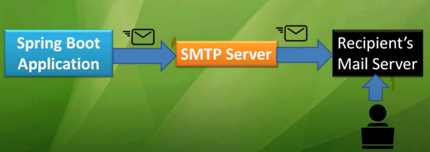

1. And the configuration that we have to make in the application.properties file to configure the mail api is also as shown below:

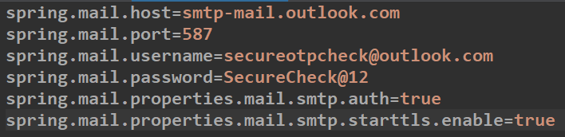

🡪In this configuration spring.mail.host, spring.mail.port will be changed according to the server and port we use for sending the email, The current data is for the gmail server, The data can be changed for different mail websites

🡪Than comes the username and password which can be changed as per our from email address

1. And than we will make a new controller in that project for send the email
2. Now the following code is for sending the plain-text email:

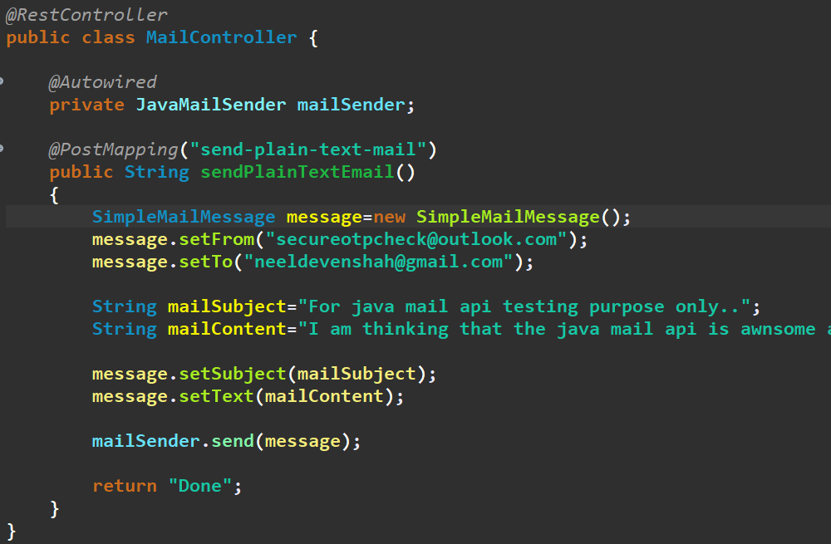

1. Now we will use the another method for sending the html document in the mail, And the code for it is as shown below:

🡪And now in the mail content in the string we can use the html tags, As shown below:

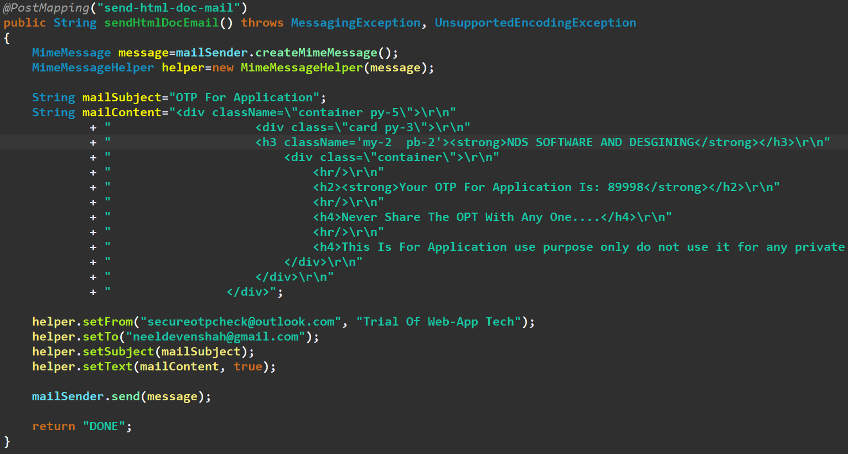

🡪The Response Of The Upper Code was like:

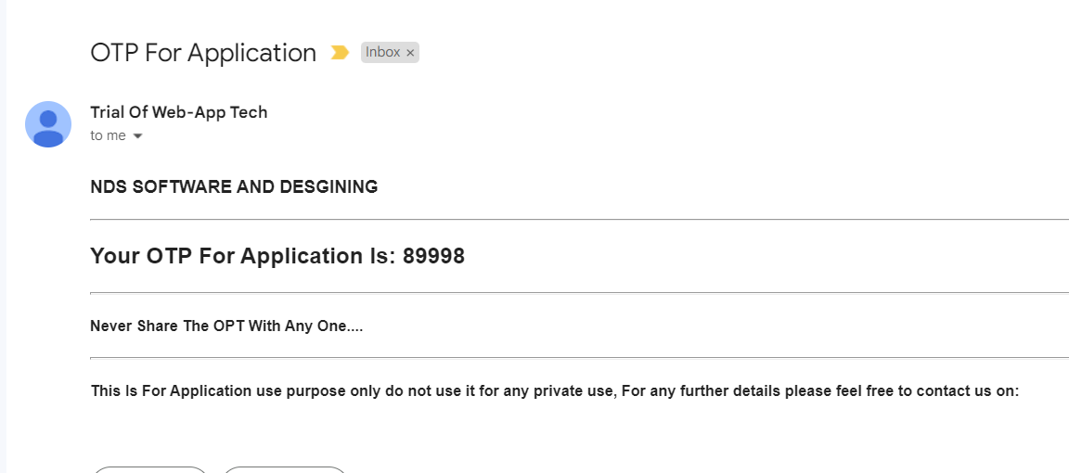

1. And for sending the image in the mail the following code is to be used:

🡪But make sure that you add the image of the name as shown in the class path to the static/image folder of the project

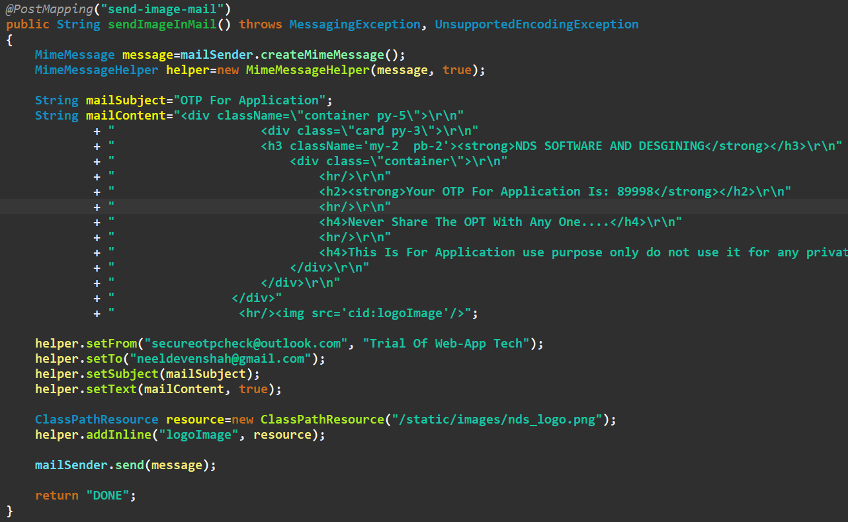

🡪The output of the upper code was like:

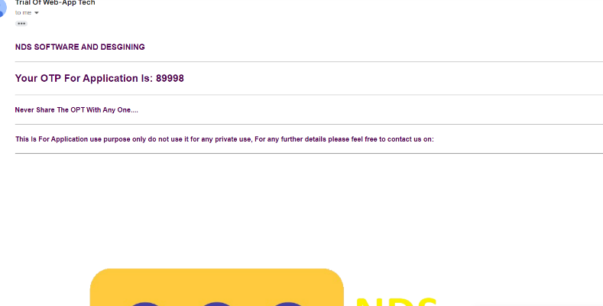

1. Now, We can also send the any file in the email, By sending that particular file or more than one file(img, pdf, or any other thing) in the request, For now we have selected the file from the postman, But in real time use the file will be selected by the system or the user form and than the mail is to be sent, Example code is as shown below:

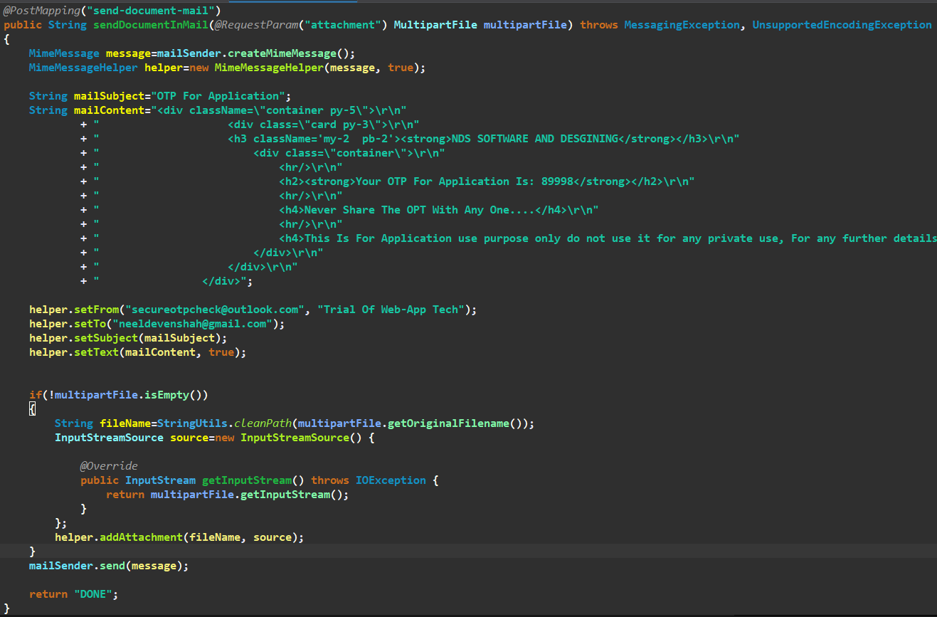

🡪And the output would be like:

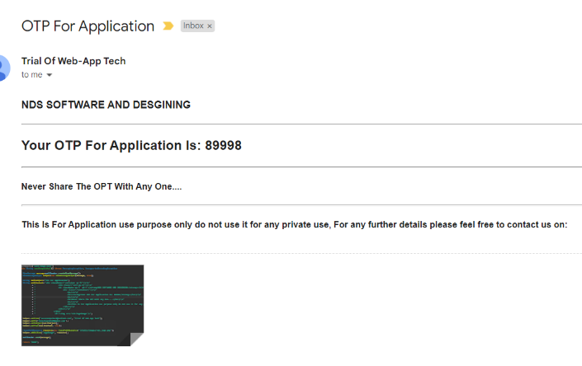

🡪And the postman request is like:

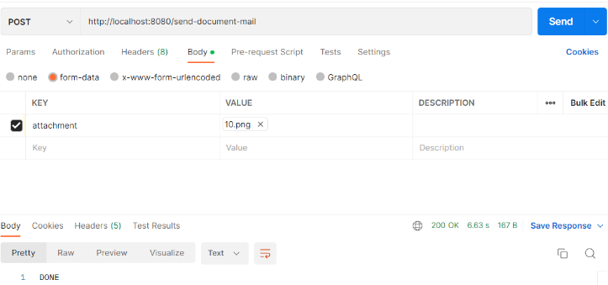

1. We can also process the sending of the main after taking the data from an form like:

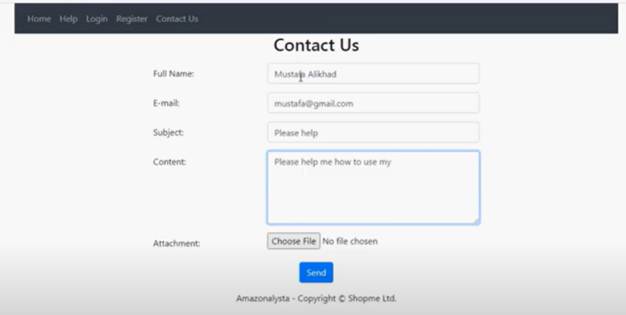

1. Make sure that you set the settings of the mail, As such that you make it able to send the mail by the third party apps